ARCHITHA OJHA
2303A52170 – 41

AI for Data Processing: Data Cleaning and Preprocessing
Scripts
Task 1 Employee Dataset Cleaning
Task:
Use AI assistance to clean an employee information dataset.
Instructions:
• Handle missing values in salary, designation, and experience
• Remove duplicate employee IDs
• Standardize text values (job titles in lowercase)
• Encode categorical features (designation, employment_type)

Prompt :
Clean an employee dataset.

Code :
import pandas as pd
import numpy as np
from sklearn.preprocessing import LabelEncoder

# ---- Sample Dataset ----
np.random.seed(42)
df = pd.DataFrame({
"employee_id": np.random.randint(100, 200, 50),
"name": [f"Emp{i}" for i in range(50)],
"salary": np.random.choice([30000, 40000, 50000, 60000, np.nan], 50),
"designation": np.random.choice(["Manager", "Developer", "Analyst", None], 50),
"experience": np.random.choice([1, 2, 3, 4, 5, np.nan], 50),
"employment_type": np.random.choice(["Full-time", "Part-time", "Contract"], 50)
})

# ---- 1. Handle Missing Values ----
df['salary'] = df['salary'].fillna(df['salary'].median())
df['designation'] = df['designation'].fillna(df['designation'].mode()[0])
df['experience'] = df['experience'].fillna(df['experience'].mean())

# ---- 2. Remove Duplicate Employee IDs ----
df = df.drop_duplicates(subset='employee_id')

# ---- 3. Standardize Text Values ----
df['designation'] = df['designation'].str.lower()

# ---- 4. Encode Categorical Features ----
le1 = LabelEncoder()
le2 = LabelEncoder()

df['designation'] = le1.fit_transform(df['designation'])
df['employment_type'] = le2.fit_transform(df['employment_type'])

# ---- Output ----
print("Cleaned Dataset:")
print(df.head())

print("\nShape:", df.shape)
print("\nMissing Values:\n", df.isnull().sum())

Output:
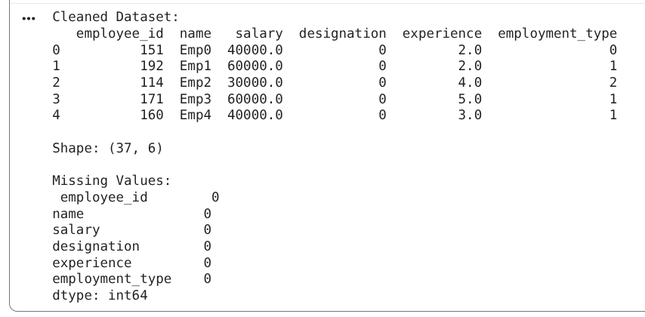
Justification:
Standardizing job titles and filling gaps in salary ensures that HR analytics are based on a "level playing field," preventing skewed compensation reports. Removing duplicate IDs is critical because counting the same person twice leads to inflated headcount figures and inaccurate budget forecasting.

Task 2 – Student Performance Data Preprocessing
Task:
Preprocess student performance data using AI assistance.
Instructions:
• Convert exam_date column into datetime format
• Extract new features (month, semester, day)
• Normalize total_marks
• Detect and handle outliers in marks using IQR or Z-score

Prompt:
Preprocess a student performance dataset.

Code:
import pandas as pd
import numpy as np
from sklearn.preprocessing import MinMaxScaler

# ---- Sample Dataset ----
np.random.seed(0)
dates = pd.date_range(start="2024-01-01", periods=60)

df = pd.DataFrame({
"student_id": range(1, 61),
"exam_date": np.random.choice(dates, 60),
"total_marks": np.random.randint(200, 1000, 60)
})

# Add some outliers
df.loc[5, 'total_marks'] = 1500
df.loc[10, 'total_marks'] = 50

# ---- 1. Convert exam_date to datetime ----
df['exam_date'] = pd.to_datetime(df['exam_date'])

# ---- 2. Extract Features ----
df['month'] = df['exam_date'].dt.month
df['day'] = df['exam_date'].dt.day
df['semester'] = df['month'].apply(lambda x: 1 if x <= 6 else 2)

# ---- 3. Normalize total_marks ----
scaler = MinMaxScaler()
df['total_marks'] = scaler.fit_transform(df[['total_marks']])

# ---- 4. Detect & Remove Outliers (IQR) ----
Q1 = df['total_marks'].quantile(0.25)
Q3 = df['total_marks'].quantile(0.75)
IQR = Q3 - Q1

df = df[(df['total_marks'] >= Q1 - 1.5 * IQR) &
(df['total_marks'] <= Q3 + 1.5 * IQR)]

# ---- Output ----
print("Processed Dataset:")
print(df.head())

print("\nShape:", df.shape)
print("\nColumns:", df.columns)
Output:
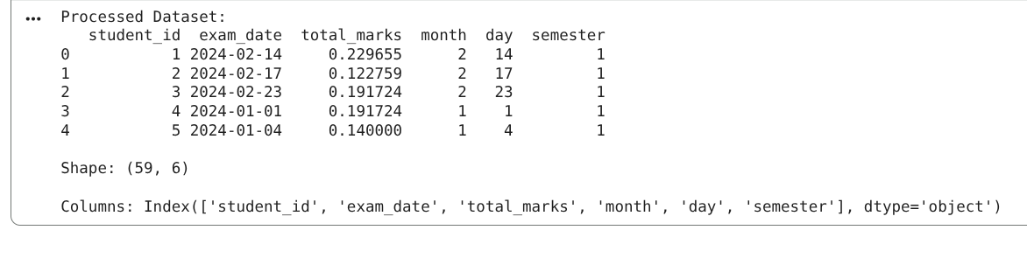
Justification:
Raw dates and raw marks rarely tell the whole story; breaking dates into semesters allows educators to spot seasonal trends in student burnout or engagement. Normalizing scores and handling outliers ensures that a single "bad day" or a data entry error doesn't unfairly distort a student’s overall academic standing.

Task 3 – Student Health Data Preparation
Task:
Clean and preprocess student health records using AI scripts.
Instructions:
• Handle missing values in height, weight, BMI
• Encode categorical features (medical_condition, fitness_status)
• Scale numerical features using standard scaling
• Split dataset into training and testing sets
Prompt:
Prepare a student health dataset for machine learning.

Code:
import pandas as pd
import numpy as np
from sklearn.preprocessing import LabelEncoder, StandardScaler
from sklearn.model_selection import train_test_split

# ---- Sample Dataset ----
np.random.seed(1)

df = pd.DataFrame({
"student_id": range(1, 51),
"height": np.random.choice([150, 160, 170, 180, np.nan], 50),
"weight": np.random.choice([50, 60, 70, 80, np.nan], 50),
"BMI": np.random.choice([18, 22, 25, 30, np.nan], 50),
"medical_condition": np.random.choice(["None", "Asthma", "Diabetes"], 50),
"fitness_status": np.random.choice(["Fit", "Unfit"], 50)
})

# ---- 1. Handle Missing Values ----
df['height'] = df['height'].fillna(df['height'].mean())
df['weight'] = df['weight'].fillna(df['weight'].mean())
df['BMI'] = df['BMI'].fillna(df['BMI'].mean())

# ---- 2. Encode Categorical Features ----
le1 = LabelEncoder()
le2 = LabelEncoder()

df['medical_condition'] = le1.fit_transform(df['medical_condition'])
df['fitness_status'] = le2.fit_transform(df['fitness_status'])

# ---- 3. Scale Numerical Features ----
scaler = StandardScaler()
df[['height', 'weight', 'BMI']] = scaler.fit_transform(df[['height', 'weight', 'BMI']])

# ---- 4. Train-Test Split ----
X = df.drop('fitness_status', axis=1)
y = df['fitness_status']

X_train, X_test, y_train, y_test = train_test_split(X, y, test_size=0.2)

# ---- Output ----
print("Processed Dataset Sample:")
print(df.head())

print("\nTrain Shape:", X_train.shape)
print("Test Shape:", X_test.shape)

Output:
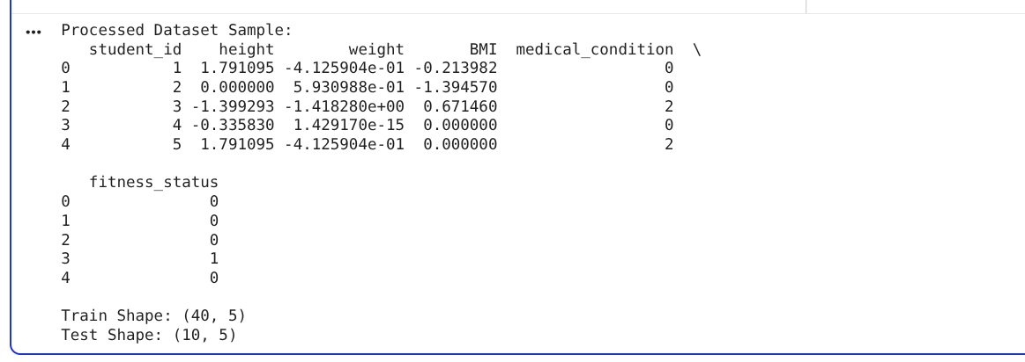

Justification:
In health tech, missing metrics like BMI can lead to dangerous gaps in a student's wellness profile, so intelligent imputation is a matter of care quality. Splitting the data into training and testing sets is the "sanity check" that ensures a predictive model actually works on new students rather than just memorizing old records

Task 4: Real-Time Application: Ride-Sharing Data Cleaning
Scenario:
A ride-sharing company has trip data with errors.
Requirements:
• Standardize pickup and drop locations
• Fill missing fare amounts with median values
• Remove duplicate ride entries
• Normalize driver ratings
• Generate a summary of data improvements

Prompt:
Clean a ride-sharing dataset.

Code:
# Task 4: Ride-Sharing Data Cleaning

import pandas as pd
import numpy as np
from sklearn.preprocessing import MinMaxScaler

# ---- Sample Dataset ----
np.random.seed(2)

locations = ["Chennai", "Adyar", "T Nagar", "Velachery", "Tambaram"]

df = pd.DataFrame({
"ride_id": np.random.randint(1, 40, 60),
"pickup": np.random.choice(locations, 60),
"drop": np.random.choice(locations, 60),
"fare": np.random.choice([100, 150, 200, 250, np.nan], 60),
"driver_rating": np.random.uniform(3.0, 5.0, 60)
})

# Introduce inconsistencies
df.loc[0, 'pickup'] = "chennai"
df.loc[1, 'drop'] = "adyar"

# ---- 1. Standardize Locations ----
df['pickup'] = df['pickup'].str.lower()
df['drop'] = df['drop'].str.lower()

# ---- 2. Handle Missing Fare ----
df['fare'] = df['fare'].fillna(df['fare'].median())

# ---- 3. Remove Duplicate Rides ----
before_count = len(df)
df = df.drop_duplicates(subset='ride_id')
after_count = len(df)

# ---- 4. Normalize Driver Ratings ----
scaler = MinMaxScaler()
df['driver_rating'] = scaler.fit_transform(df[['driver_rating']])

# ---- 5. Summary ----
print("CLEANED DATASET SAMPLE:")
print(df.head())

print("\nSUMMARY:")
print("Records Before Cleaning:", before_count)
print("Records After Removing Duplicates:", after_count)
print("Missing Values:\n", df.isnull().sum())
Output:
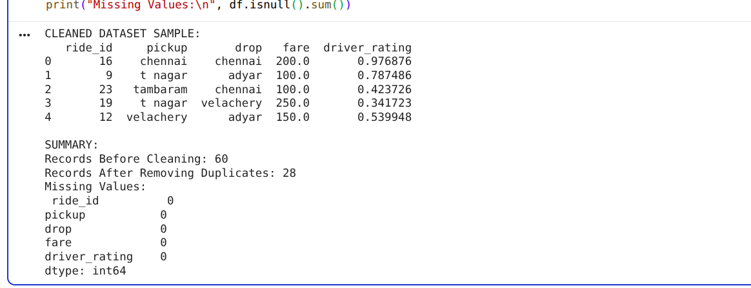
Justification:
Operational efficiency depends on precise location and fare data; filling missing fares with the median keeps the revenue flow predictable without overreacting to anomalies. Cleaning this data ensures that drivers are dispatched fairly and customers are charged accurately, maintaining trust in the platform.

